All About Emojis
Whether you 😍 or 😠 emojis, they’re a part of modern life. Here’s how they’re created.
SEPTEMBER 23, 2019

By Jacob Batchelor
AS YOU READ, THINK ABOUT the steps in the design process used to create an emoji.
Every day, people send billions of emojis to one another via text messages and posts to social media sites like Twitter and Facebook. We rely on these tiny images to express what we’re feeling when we can’t see 🙈 or hear 🙉 who we’re chatting with. But where do these cute icons come from ? Next time you send a ❤️ or a 👍, there’s a group of computer scientists you should thank.
A Brief History of Emojis
Watch a video about how emojis developed over time, if you have internet access at:
https://bit.ly/33mSbe5
The Unicode Consortium is a nonprofit organization made up primarily of people from tech companies such as Apple, Google, and Adobe. It’s tasked with managing the world’s emojis by assigning each a unique alphanumeric code, consisting of letters 🔤 and numbers 🔢. Any smartphone, tablet, or computer 💻 can translate these codes into their corresponding emojis.
Each year, Consortium members meet to review more than 100 proposals for new emojis—about 50 get chosen. The group uses several factors to decide which ones get approved. Emojis must be easily recognizable ✅, likely to be used by many people ✅, and useful for communication ✅. No company logos or depictions of real people are allowed ❌.
DISTINCT DESIGNS
Different tech companies often have their own unique visual representation for an emoji, like the telescope.
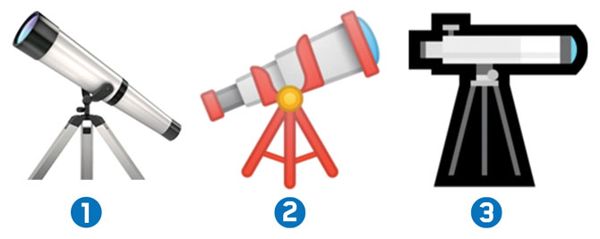
APPLE; GOOGLE; MICROSOFT

The Consortium also tries to add emojis that are diverse and inclusive. In 2015, emojis became available in a range of skin colors 👩🏽‍⚕️ 🙋🏻‍♂️ 👩🏾‍🎓. In 2017, the group approved an emoji depicting a woman wearing a hijab, or head scarf. And this year, a new set of emojis will represent people with disabilities.
Anyone can propose a new emoji—even teens, like you ✊! In fact, a 15-year-old named Rayouf Alhumedhi came up with the idea for the hijab emoji. She sent the idea to Unicode—noting that 550 million Muslim women, like her, wear a head scarf every day. A member of the committee worked with Rayouf to hone her proposal, including coming up with an emoji design. Because of her, an underserved community is now represented digitally around the world 🌍. It turns out a little picture can say a lot! ⚛️
MORE AND MORE EMOJIS
Over the past decade, the number of emojis has skyrocketed 📈. About how many emojis have been added since 2009?
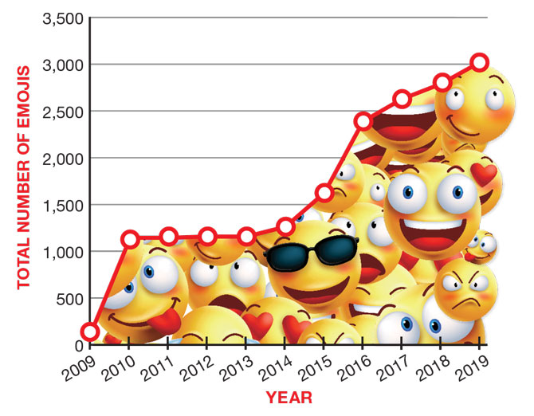
SOURCE: EMOJIPEDIA
Continue the Learning Journey
- Let's tell a story! Emojis are important for modern communication. Try to write your own short story using ONLY groups of emoji characters. (If you can't think of your own story, try telling the story of your favorite movie or book!) When you're done, you can challenge a friend or family member to decode your emoji story. This is due Friday, March 20
- If you can, watch the “All About Emojis” video at https://bit.ly/33mSbe5. At the end of the video, the host asks: “What kinds of emojis would you like to see in the future?” Which emojis do you think are missing? It's your turn to come up with an idea for a new emoji—sketch a design in your notebook, and write a short paragraph describing it. What does it look like? What category is it in? How do you think people will use it when they're sending a text? If you can’t watch the video, still answer all of the questions. This is due Friday, March 27.

- You can always work on your typing skills on www.typing.com or nitrotype.

