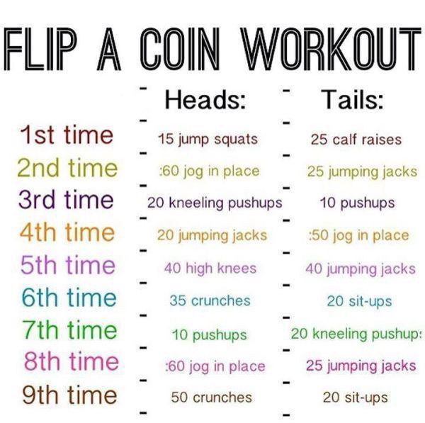
Complete two times on each day, Tuesday and Thursday

