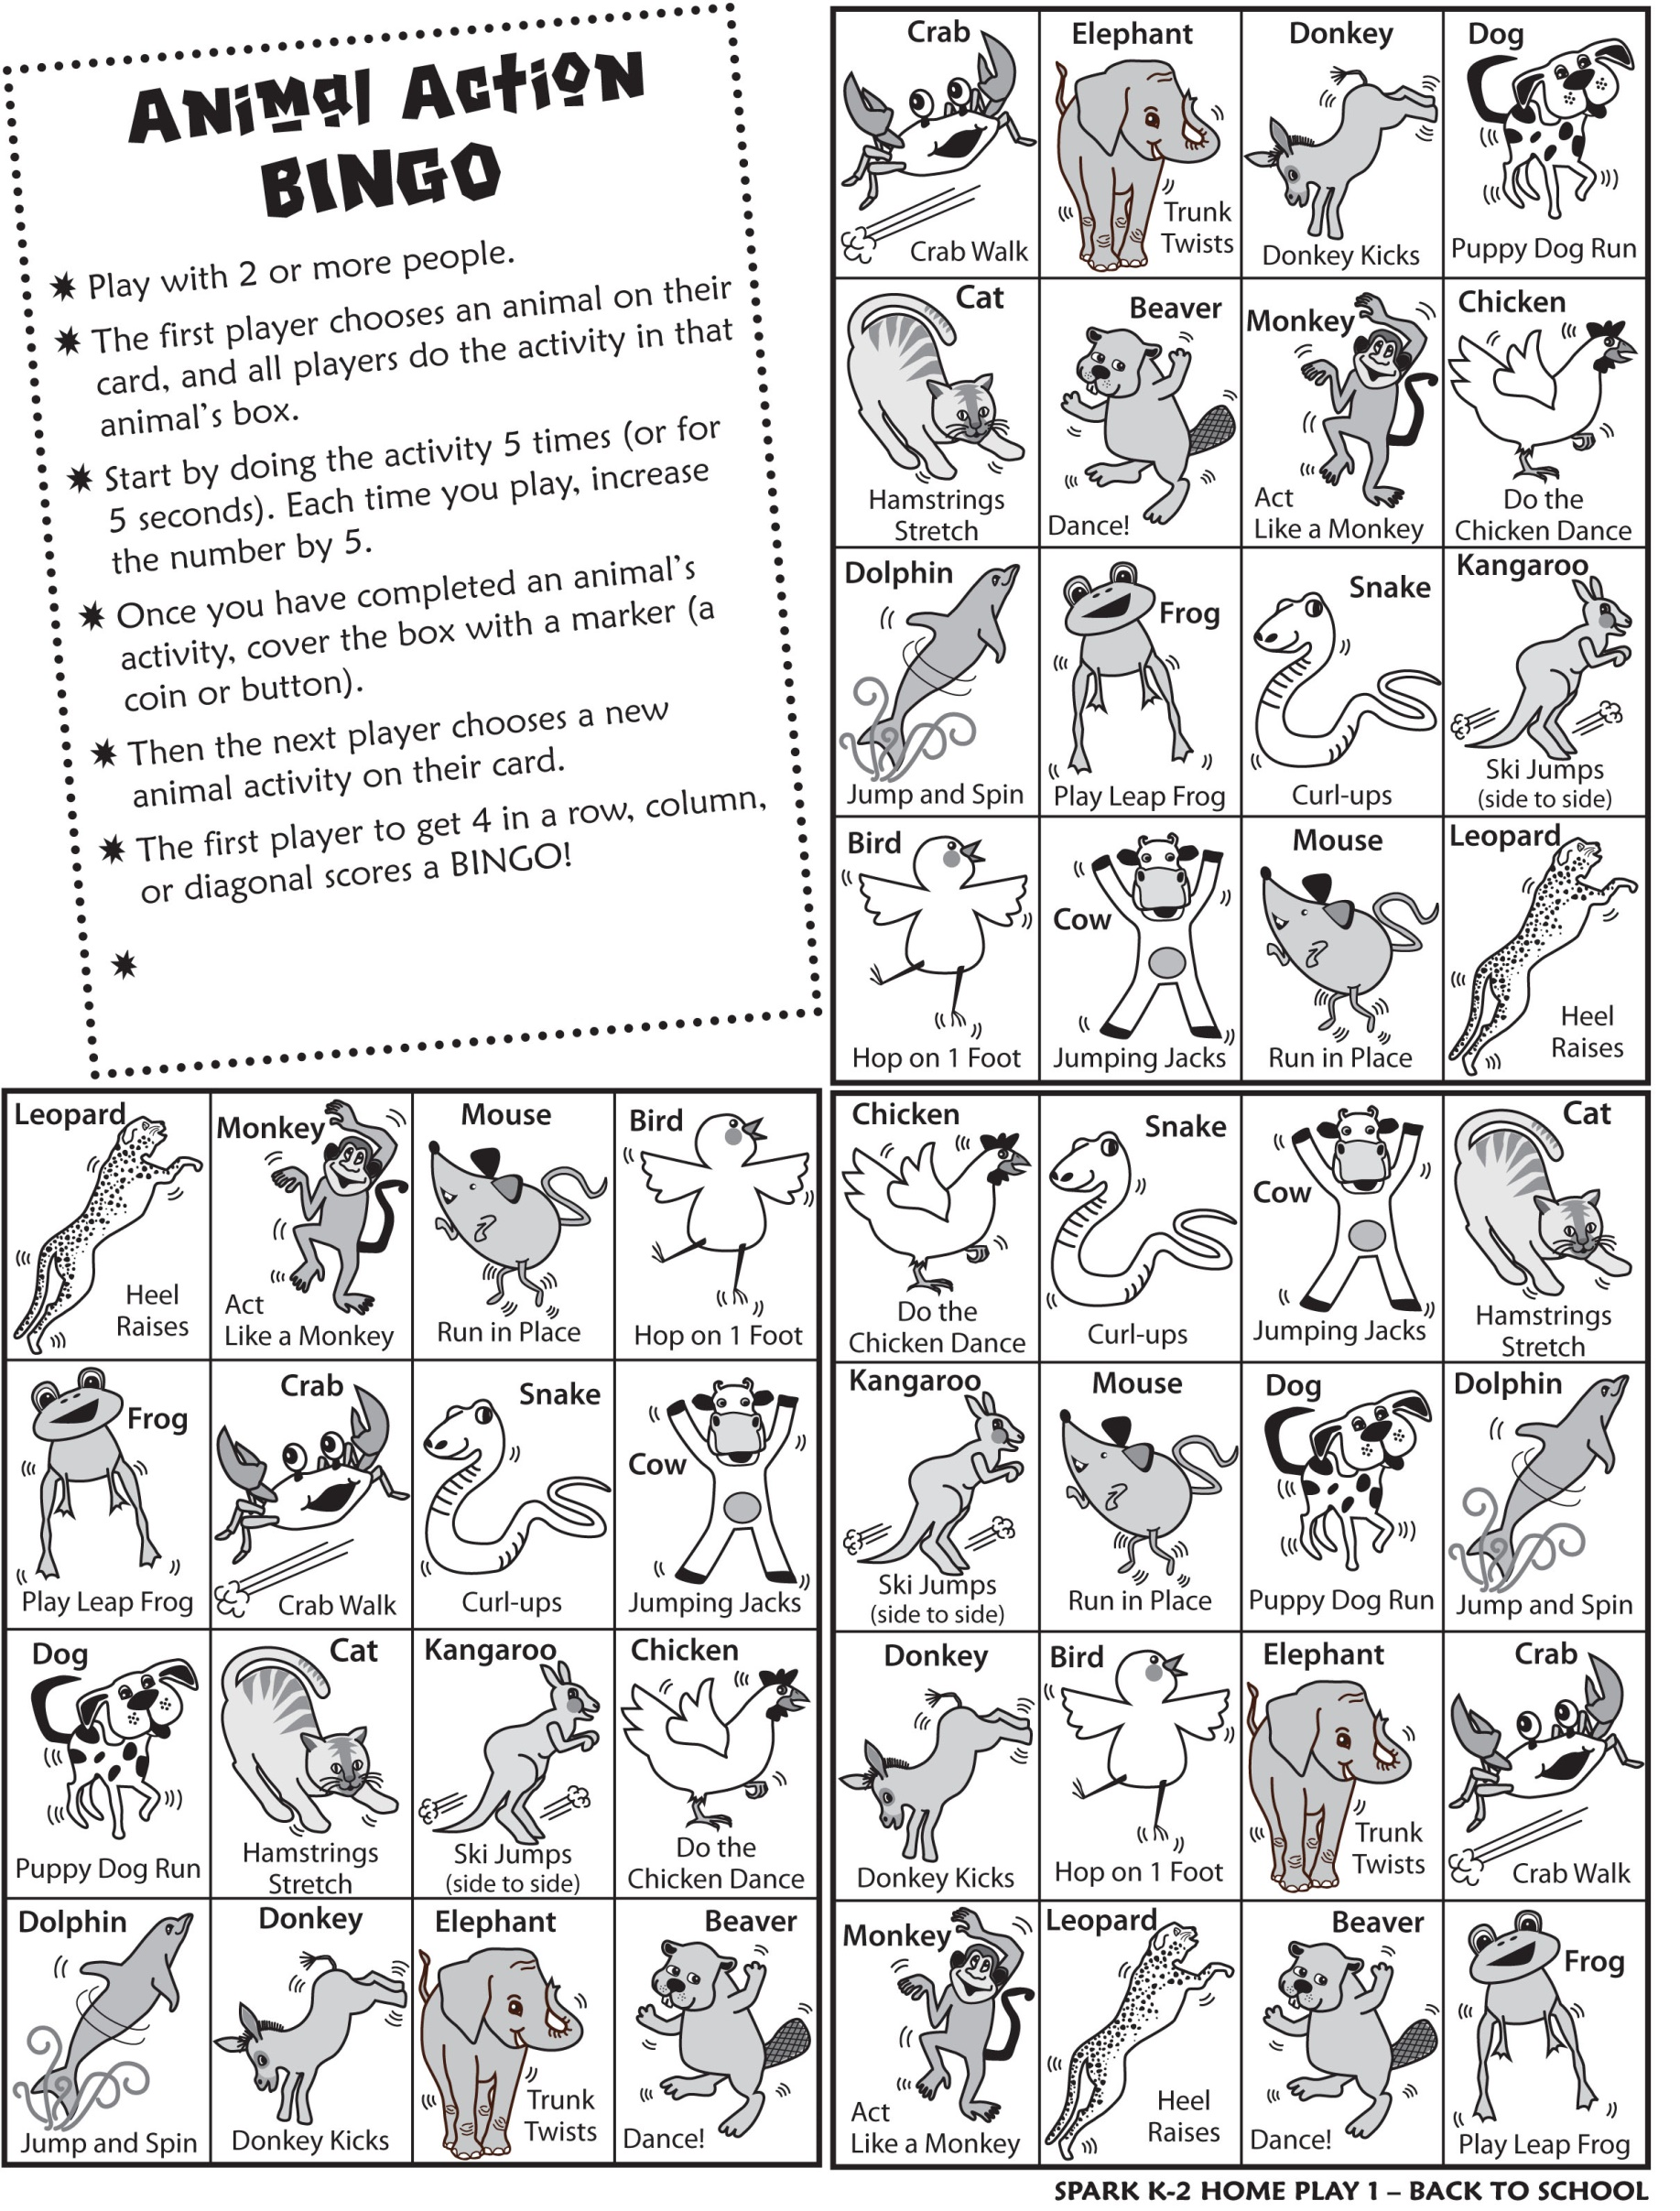

Cut out each Bingo Board and have FUN!!